**Database Development and Class Registration**

Orane Sappleton

The University of Arizona Global Campus

GEN 499: General Education Capstone

Dr. Butler

January 26, 2025

**Figure 1**

*Homepage/Landing Page*

**Figure 2**

*Homepage Source Code*

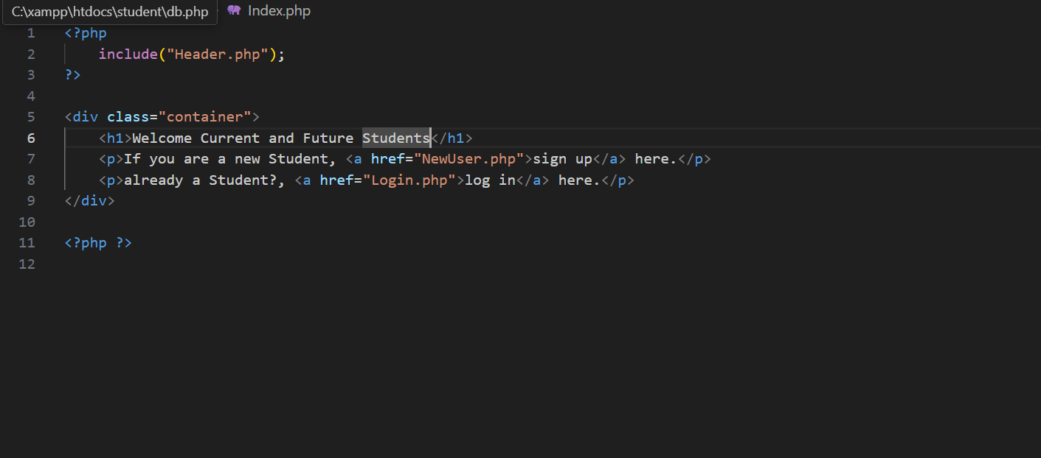

**Figure 3**

*Login Page*



**Figure 4**

*Login Source Code*

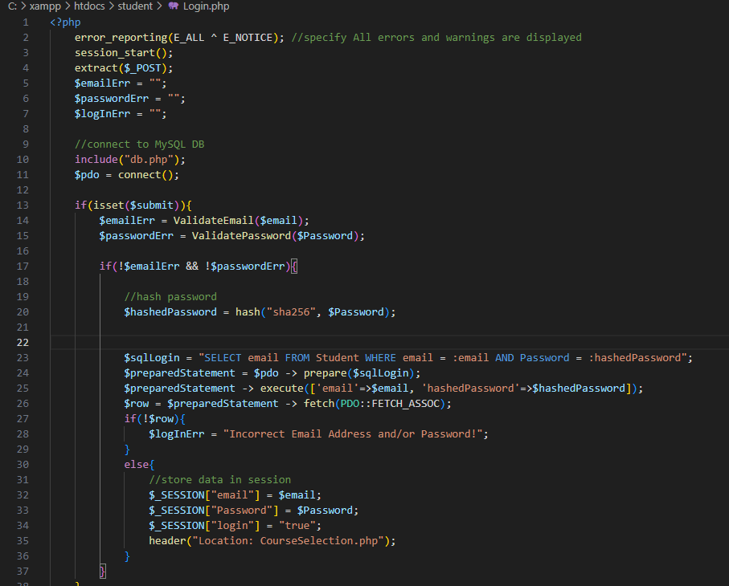

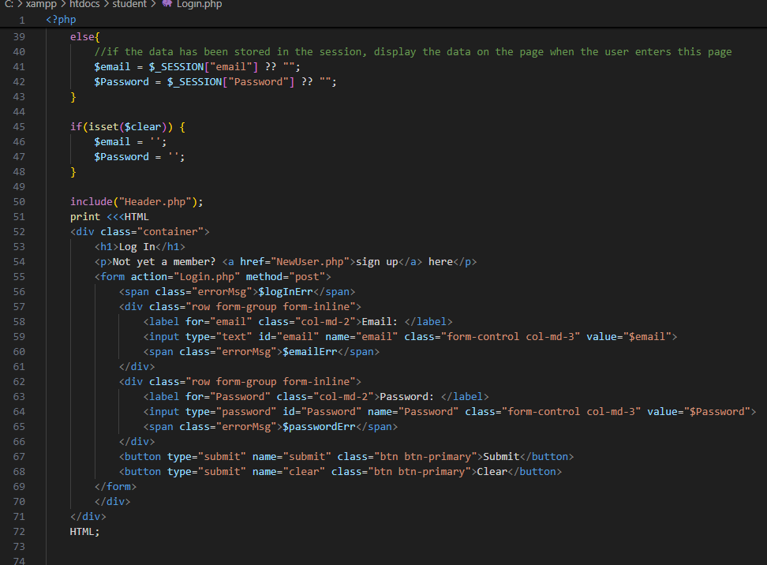

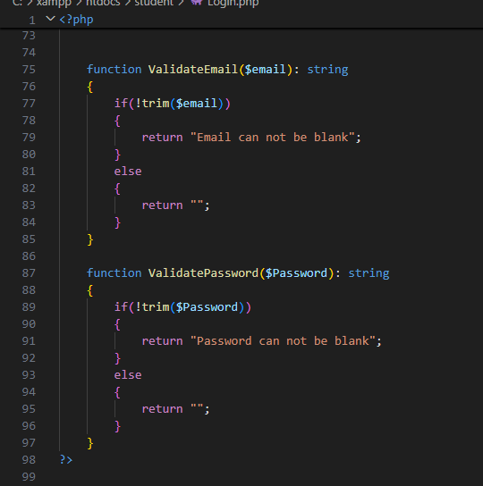

**Figure 5**

*Registration Page*

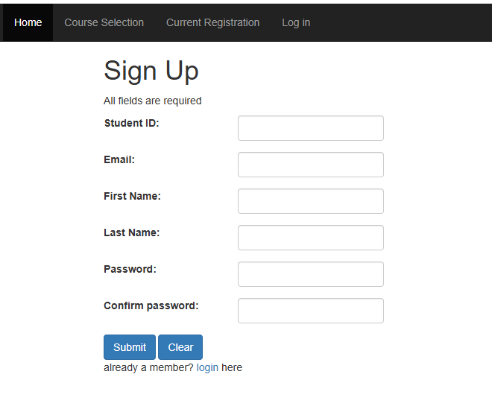

**Figure 6**

*Registration Source Code*

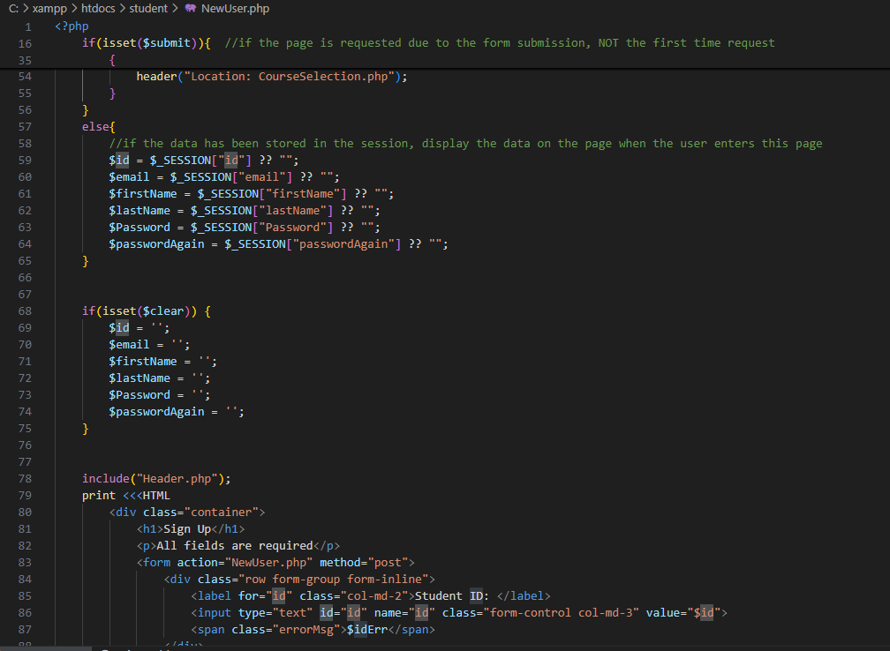

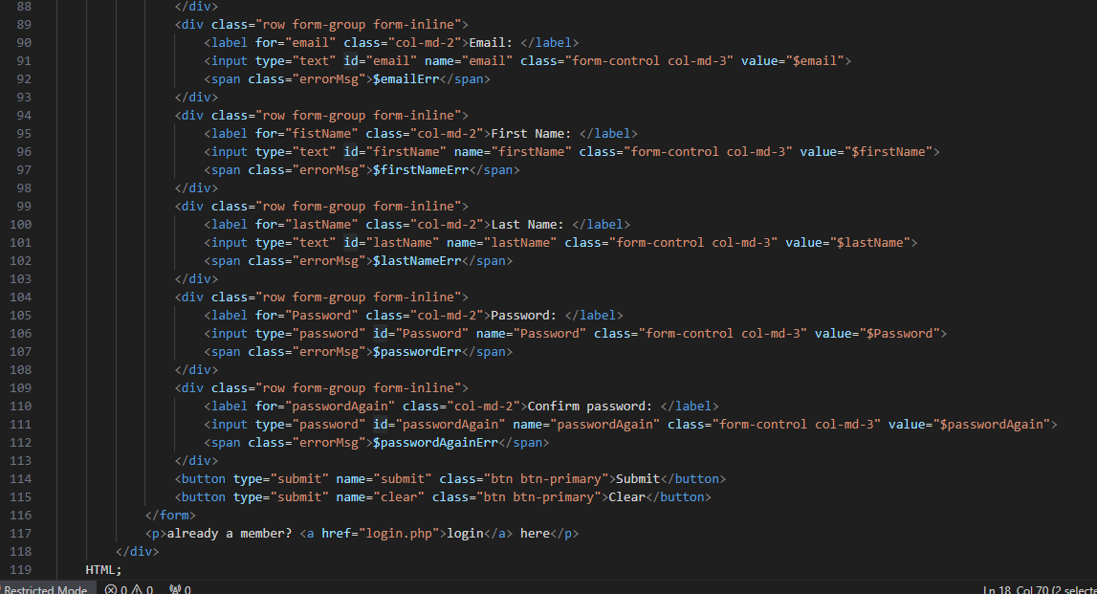

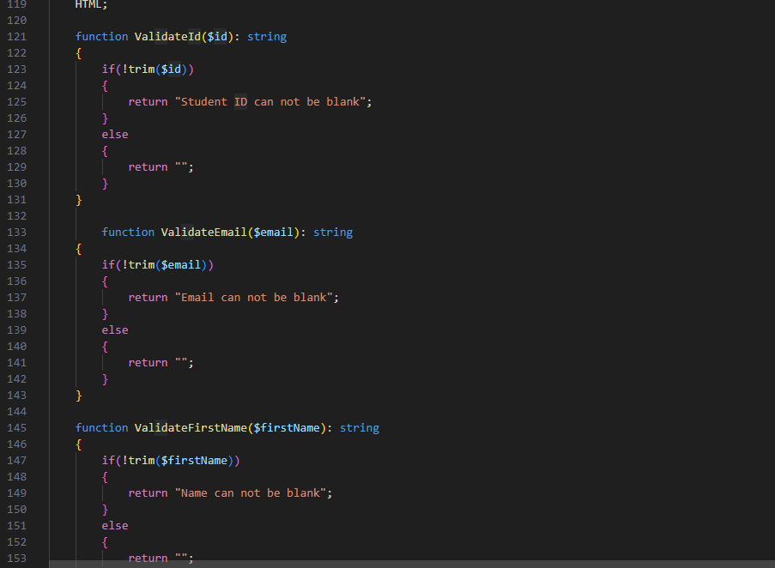

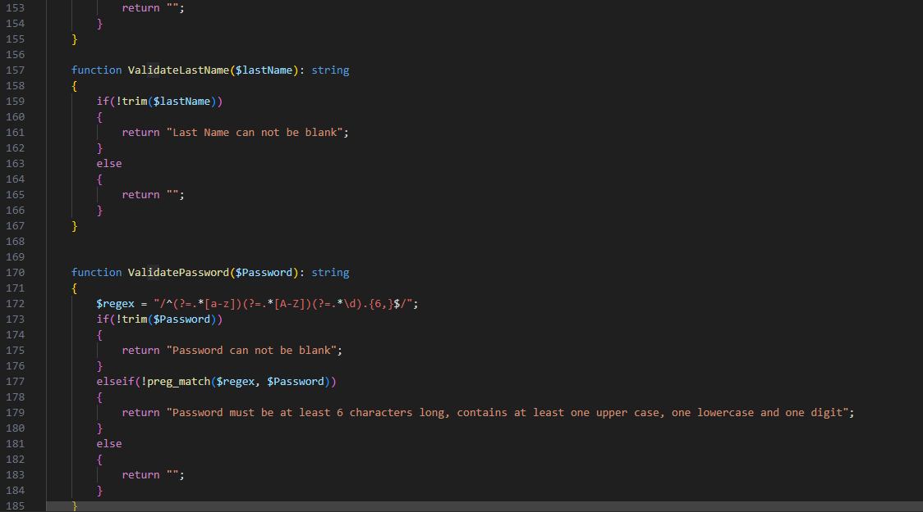

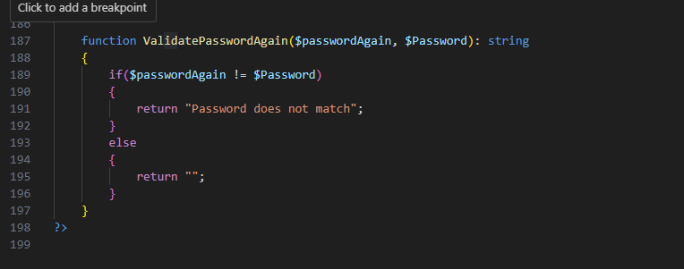

**Figure 7**

*Database*

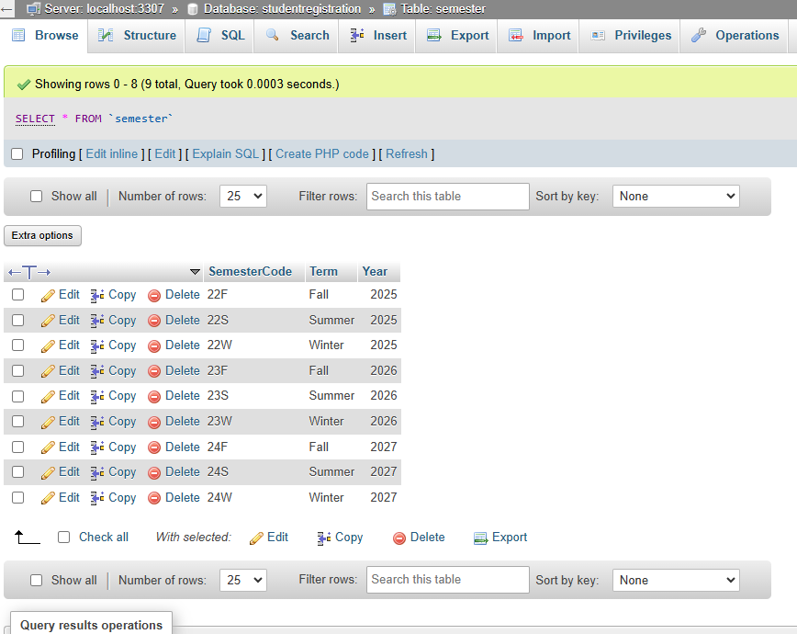

**Figure 8**

*courses Table*

**Figure 9**

*Course offered table*

**Figure 10**

*Registration table*

**Figure 11**

*Semester Table*

**Figure 12**

*Student table*

**Figure 13**

*Course Selection page*

**Figure 14**

*Enrolled courses page*

**Figure 15**

*Course selection source code*

**Figure 16**

*Enrolled courses source code*

